Name : Dhavalkumar Vijaykumar Patel
Subject : Essential of Cyber Security and Cyber Waefare
Class : M.Sc Cyber Security
Semester : 1

Lab 6 :

- Nmap – multi-functional scanning and enumeration utility used to quickly gather info about network hosts (incl. their availability, ports, IP addresses, names, their OSs, services they run).
Used by hackers as the first attack step
$ sudo nmap -A -Pn -O 10.0.2.8
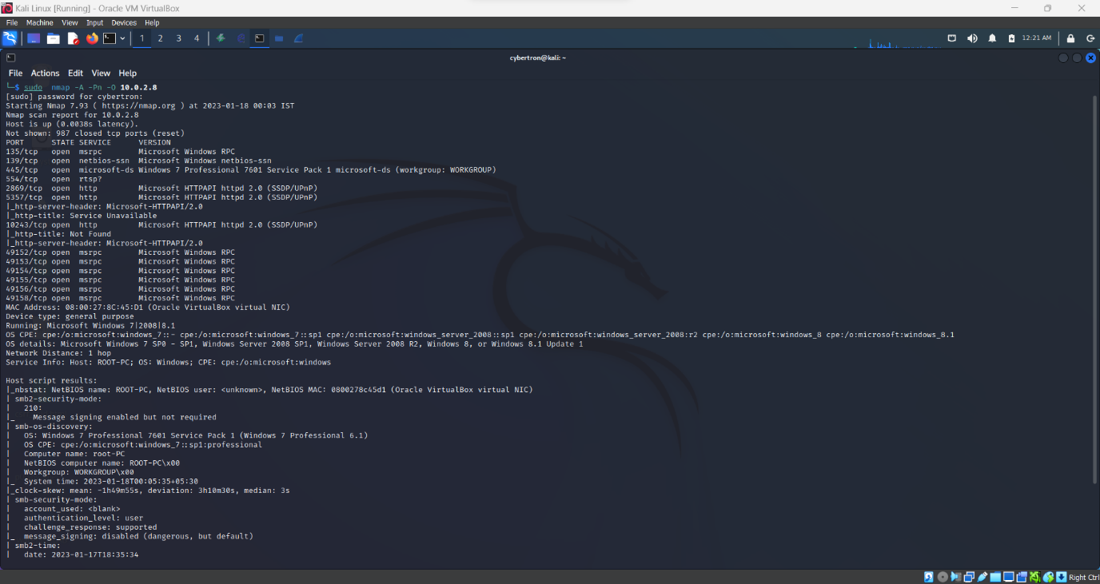

- Banner Grabbing
$ nmap -sV --script=banner 10.0.2.8


